## Jannik Klauke

API is short for Application Programming Interface. It allows users to interact with the underlying functionality of some written code by accessing the interface.

Web API allows users to interact with functionality over the internet.

In this example, we are building an API that will provide predictions through our trained machine learning model.

An example of a publicly available machine learning API is [Time Door](https://timedoor.io/). It provides Time Series tools that you can integrate into your applications. APIs can also be used to [make data available](https://www.statworx.com/en/content-hub/blog/making-of-a-free-api-for-covid-19-data/" \t "_blank), not only machine learning models.

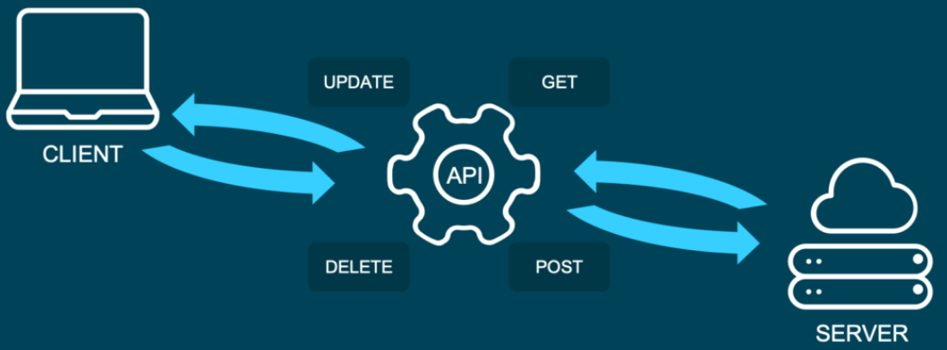

**And what is REST?**

Representational State Transfer (or REST) is an approach that entails a specific style of communication through web services. When using some of the REST best practices to implement an API, we call that API a “REST API”. There are other approaches to web communication, too (such as the Simple Object Access Protocol: SOAP), but REST generally runs on less bandwidth.

In a REST API, the four most important types of requests are:

* GET
* PUT
* POST
* DELETE

For our little machine learning application, we will mostly focus on the POST method, since it is very versatile, and lots of clients can’t send GET methods.

It’s important to mention that APIs are stateless. This means that they don’t save the inputs you give during an API call, so they don’t preserve the state. That’s significant because it allows multiple users and applications to use the API at the same time, without one user request interfering with another.